**MODULE 3**

**Reading and Writing Skills**

**Narration, Description and Definition**

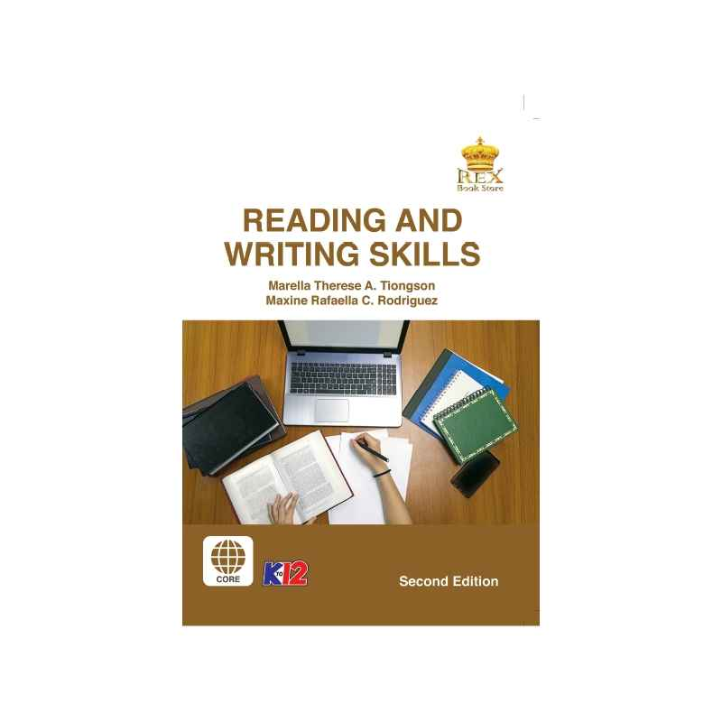

***Prepared by:***

**Mr. Reymart T. Metrillo**

Subject Teacher

**Name of Student**

**Grade,Section and Strand**

Date: ________________________

**MODULE 3:** **Narration, Description and Definition**

**Narration**

Developing one’s reading and writing skills is not easy. There are learners who can read but are not able to express themselves in writing well. You have a lot of ideas in mind but sometimes you may find it hard to organize these ideas coherently, however, the good thing is that there are many ways on how you can write effectively.

We have learned in our previous lesson that written text as connected discourse is formed from spontaneous discreteness that predetermined its connectedness. It means that the text itself does not have meaning and its meaning can be determined by their connectedness. We also learned techniques in selecting and organizing information by identifying relevant and irrelevant ideas or information.

After learning these skills in organizing information, you must learn some writing patterns on how you can develop paragraphs.

Writing a paragraph involves deep understanding of how one can achieve well focused and unified ideas in a composition. For example, when students are asked to come up with a summary of a story, they tend to chop parts of the story and put it in their summary. If that is so, it leads to create unrelated details that do not contribute in the oneness and clarity of one’s summary.

It is important to use strategies developing ideas using a particular pattern. One of these is through narration. A narrative text contains the plot which gives direction in making a story.

In developing narration, sequential presentation of events plays an important role.

Signal words help to create unified thought and to show the transition of events to the next. This leads us to focus on the use of the action words in the story. It also helps to move the story and makes the story interesting.

The chronological ordering of events helps to show the reader how the story moves.

Most of the common transitional words are first, next, then, after and suddenly.

Moreover, it is also important to give specific details in pointing out the direction of the story

**Description**

People love to read and listen to story and the use of appropriate transitional devices in telling stories are noteworthy. Likewise, you have previously learned that in writing a narrative, the plot gives direction in making the story. However, it is not only the plot that will help you to develop your writing skills. The use of description is also important to help you create a vivid picture of what you are trying to express through written text.

According to Dayagbil & et al, 2016, the use of description plays an important role to elucidate the nature of people, places and things. A series of detailed observation about the subject can help you create a good descriptive paragraph. This involves the use of adjectives and adverbs in the paragraph.

The kind of words we used to describe how your subject looks, sounds, feels, smells or even tastes like are called sensory languages. It also concerns how you will arrange the details to provide an image of the scene, the person or the object you are trying to describe in your text.

There are two types of description. First is objective description, where the writer presents impartial and actual picture of the subject without biases and excluding personal impression of the subject just like when you give your description of an experiment in class. Second is subjective description, where the writer gives personal impression of what is observed. This is often used in making fiction stories. For instance, when you are asked to write about a place you visit during summer vacation, you tend to give your personal judgment of how you experience the place.

**Definition**

Previously, you have learned the first two patterns of development: narration and description. The descriptive text portrays events and brings a scene or object to life in the imagination of the reader. Meanwhile, a narrative text tells story or events in chronological order. Now, let’s move on to another pattern which is called definition.

Definitions provide concise but exact meanings of unfamiliar words and explain special meanings for familiar words. They are often used to explain technical words and concepts. What to define always depends on the needs of the reader and the purpose of communication. It can be done in either of the two distinct methods of definition. First informal definition as either denotation or connotation. Denotation is the dictionary meaning of the word. For example: Rose is a family of prickly shrub with pinnate leaves and showy flowers. Meanwhile, connotation is the secondary meaning of a word and not necessarily included in the dictionary. Rather it is how a writer understands a word based on their own personal or consensual experiences.

In the example: A dozen of pink roses is usually given to their beloved ones. Instead of literally referring to flowers, love and romance are connoted.

Second, formal definition consists of three principal parts: the species (WORD) n + Genus (CLASS) + Differentiae. The WORD is the name of the object, process, or concept defined. This is usually followed by “is” and “are” and the CLASS or general group to which the objects belongs. For example: Skimming (species) is a reading technique (class) of allowing the eyes to travel over a page very quickly, stopping only here and there to gain an idea (differentiae).

For the expanded or extended definition, the following are common methods used in paragraph development would be of great help (Filomena T. Dayagabil, Ethel L. Abao, and Remedios C. Bacus, Critical reading and writing for Senior High School. Quezon

City: Lorimar Publishing, 2016, 43:

|  |  |
| --- | --- |
| Methods | Examples |
| By stating its  characteristics | San Pablo City is one of the oldest towns in the Philippines and today, it is known as one of the first-class cities in the province of Laguna. It is also called the City of Seven Lakes namely: Bunot Lake, Calibato Lake, Mohicap Lake, Palakpakin Lake, Pandin Lake, Sampaloc Lake, and Yambo lake. These seven freshwater lakes are crater form of a steam-blast eruption from Mt. Cristobal. |
| By function | In this time of global crisis, everyone is responsible for their actions, such as following the precautionary measures given by the health experts to avoid the spread of the virus. |
| By what it is  not | Far from the normal situations that we had before, the pandemic makes each one of us skip buying unnecessary items. |
| By what it is  similar to | Jollibee and McDonalds both offer savory chicken and delicious pasta that children love. |
| By Examples | The opening of the classes for School Year 2020 -2021 amidst the pandemic is a great challenge to the Department of Education. They continue researching different alternative ways of teaching and learning to be implemented in schools such as online learning, modular learning, and lastly learning from TV shows and radio programs. |
| By origin of word or  etymology | Writers around the world define literature in different ways. The origin of the word literature is derived from the Latin word Litera which means letter. |
| By its effect | Due to the global pandemic, specifically COVID-19, the world embraces the new normal. People have become more conscious about sanitation and hygiene. They now learn physical distancing in public places. And, most of the people stay at home either working or developing new hobbies and exploring new things. |

**QUIZ 3  
Direction:** Read definition and Identify what is being asked. Choose your answer inside the box below.

|  |  |  |
| --- | --- | --- |
| Chronological Ordering |  | Narration |
| Transitional Devices | Plot | Sequencing |

1. _________ is a writing pattern that is used to tell story.

2. A narrative text contains the _________ which gives direction in the story.

3. _________are words or phrases that help carry a thought from one sentence to another, from one idea to another, or from one paragraph to another.

4. Most of the common transitional words to show _________ of events are first, next, then, after and suddenly.

5. The _________of events help to show the reader how the story moves.

|  |  |  |
| --- | --- | --- |
| Objective | Subjective | Description |
| Sensory languages | Modifiers |  |

6. ____________ is a writing pattern of developing paragraph using detailed observation about the subject.

7. ____________ are used in writing descriptive paragraph.

8. ____________ can be in a form of word, phrase or clause.

9. ____________description presents impartial and actual picture of the subjects without biases.

10. ____________ description gives the personal impression of the writer

**Direction:** Create a semantic map in a bond paper/clean paper. Write all your key learning from this lesson. 10pts

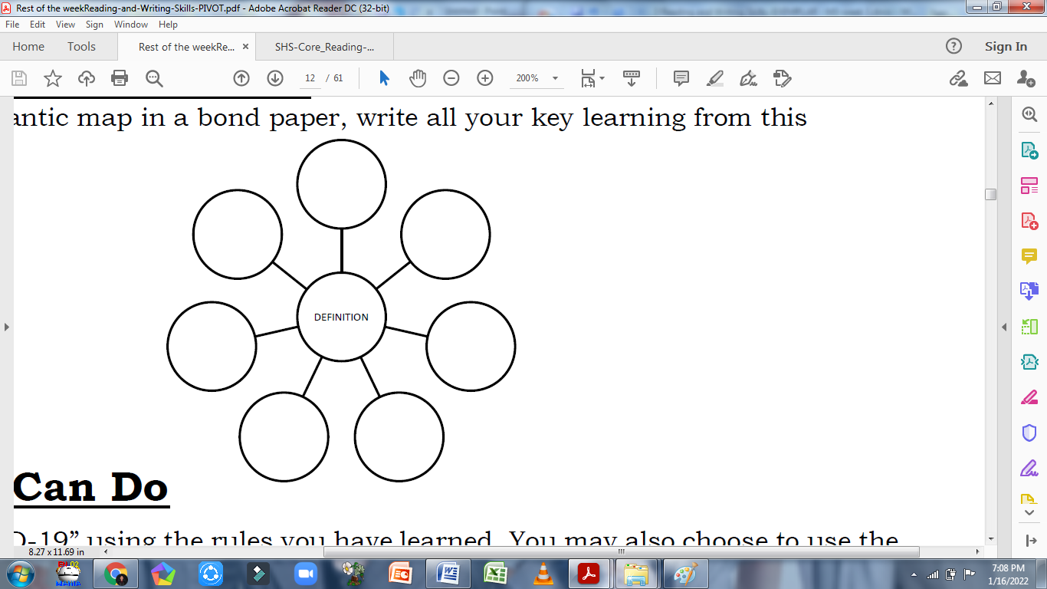

**ACTIVITY 3**

**Direction:** Analyze how the writer creates a shared concept and what different expanded definition methods are used in the paragraph. Write your answer on a separate sheet of paper. You may follow the template below:

Bimetallic Components

1Bimetals are components made up of two separate metallic units, each occupying a distinct position in the component.2Bimetal rods or wires (also called clad metal, duo- or dual-metal) are made of dissimilar metals.3The rod core a cylindrical body made of one metal, is surrounded by a concentric, cylindrical bsleeve of another metal. 4 Some fibrous metals may also be regarded as bimetallic; for example, rods made by unidirectional solidification of some eutectic compositions containing a metallic (or nonmetallic) compound of fibrous filaments embedded in an almost pure metallic matrix.5The structure of presentday Nb-SN superconducting core can be even more complex. 6It is multimetalliccontaining more than two dissimilar metals. 7The two elements of a bimetallic product are usually intimately interlocked, so that they function in unison. 9Bimetal rods or wire stems make it possible to combine properties of dissimilar metals. For example: 9Aluminum-clad steel wire combines the strength of steel with the electrical conductivity and corrosion resistivity of aluminum. 10Superconductor core clad with copper sleeves combines superconductivity at cryogenic temperatures with assurance against failure when a local temporary rise in resistance or temperature occurs.11Although the number of desired bimetallic combinations for practical use isv virtually unlimited, manufacturing difficulties restrict the number of bimetallic combinations actually in use.

|  |  |
| --- | --- |
| Method used | Sentence/s |
|  |  |
|  |  |
|  |  |
|  |  |
|  |  |

**REFLECTION:**

The learners will write their personal insights about the lesson using the prompt below.

1. The process of making a simple academic is easy or hard?

2. What method or techniques will you apply or integrate to your future work?